Abingdon IPMS Web Site Maintenance Document – V1

1 – Sign on 1

Enter
http://www.abingdonipms.co.uk/wp-login.php?loggedout=true
click on ‘Log in with username and password’

Username or Email Address = admin
Password = (second letter is zero) Do not change this until we are confident/happy to fly
without the web Master!

Tick box Remember Me
Click on Log in
This will be used to make the changes to the pages and be called Edit Window 1

2 – Sign on 2

Open another internet window, as per:
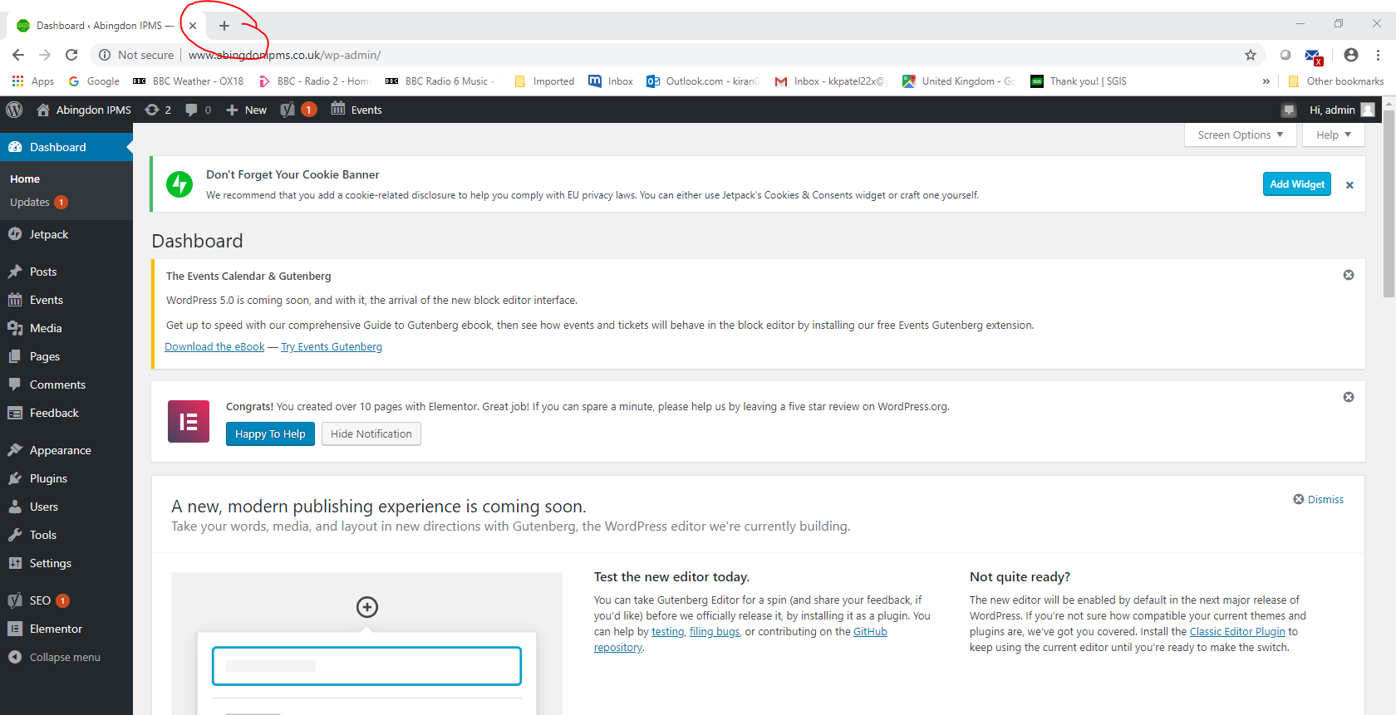

Enter www.abingdonipms.co.uk
This will be used to view the changes made and be called Browse Window 2

Note it’s a good idea to open up a third window and use sign on 1 details to sign in. This third window is needed for some tasks but not all and will be called Edit Window 3.

As per:
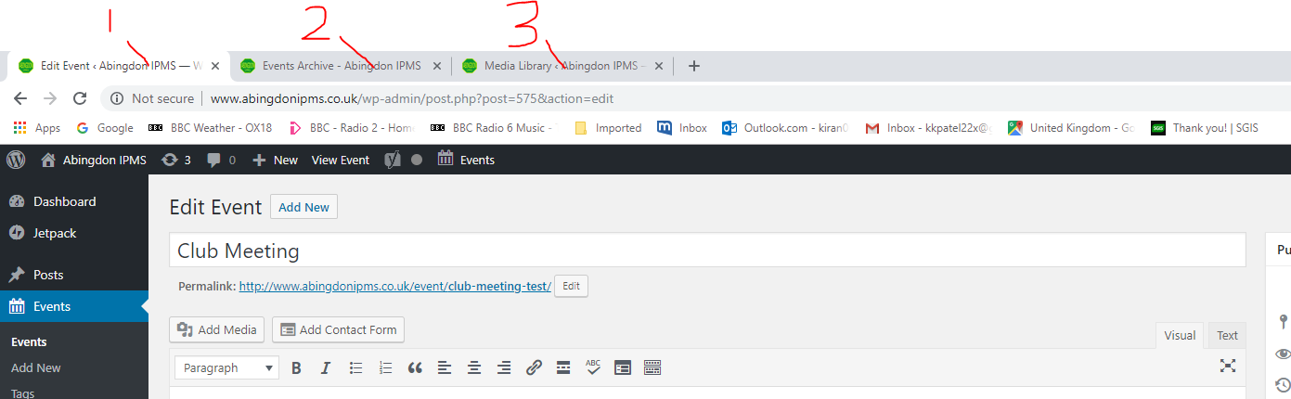

3 – Dashboard

After signing on with 1 (the Edit Window 1)
This now brings you into the ‘Dashboard’ as per:

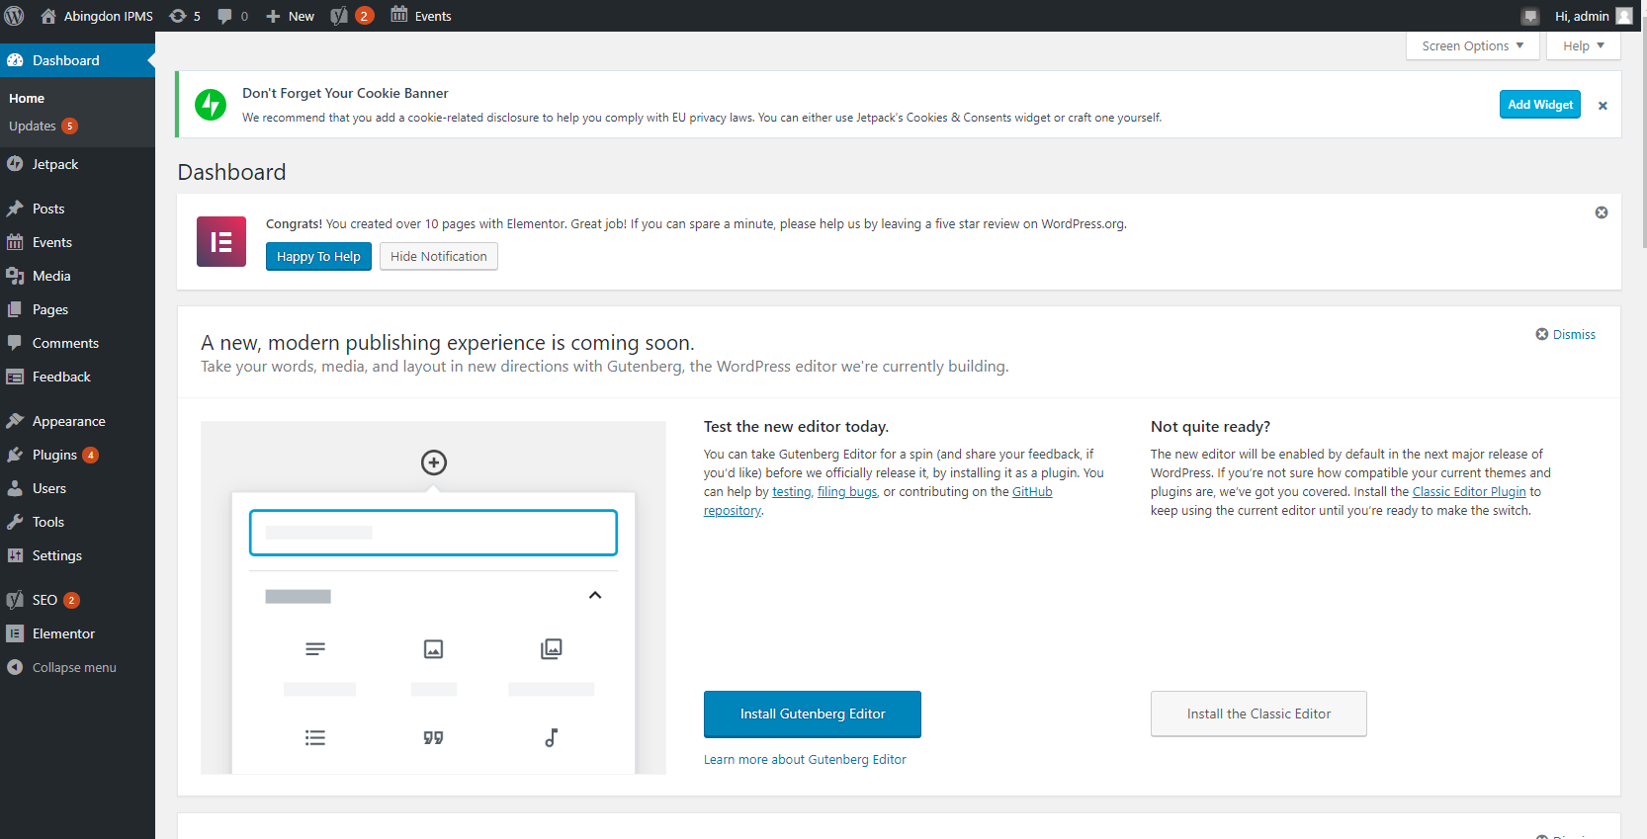

We have entries in
Events – this is where the calendar entries for our meetings resides
Media – Holds our images, PDF’s and other items that we wish to display
or attach to pages.
Pages – These contain the tabs on our page ie Home, About us, Shows etc etc
4 – Elementor

We are using a tool called ‘Elementor’ to modify pages and events which we
will see in our examples to follow. So we flick in & out of dashboard & Elementor.

How to change the next meeting date
(perform every 2 weeks on Wednesday morning)

1 – In Edit Window 1, Click on Pages and we get:

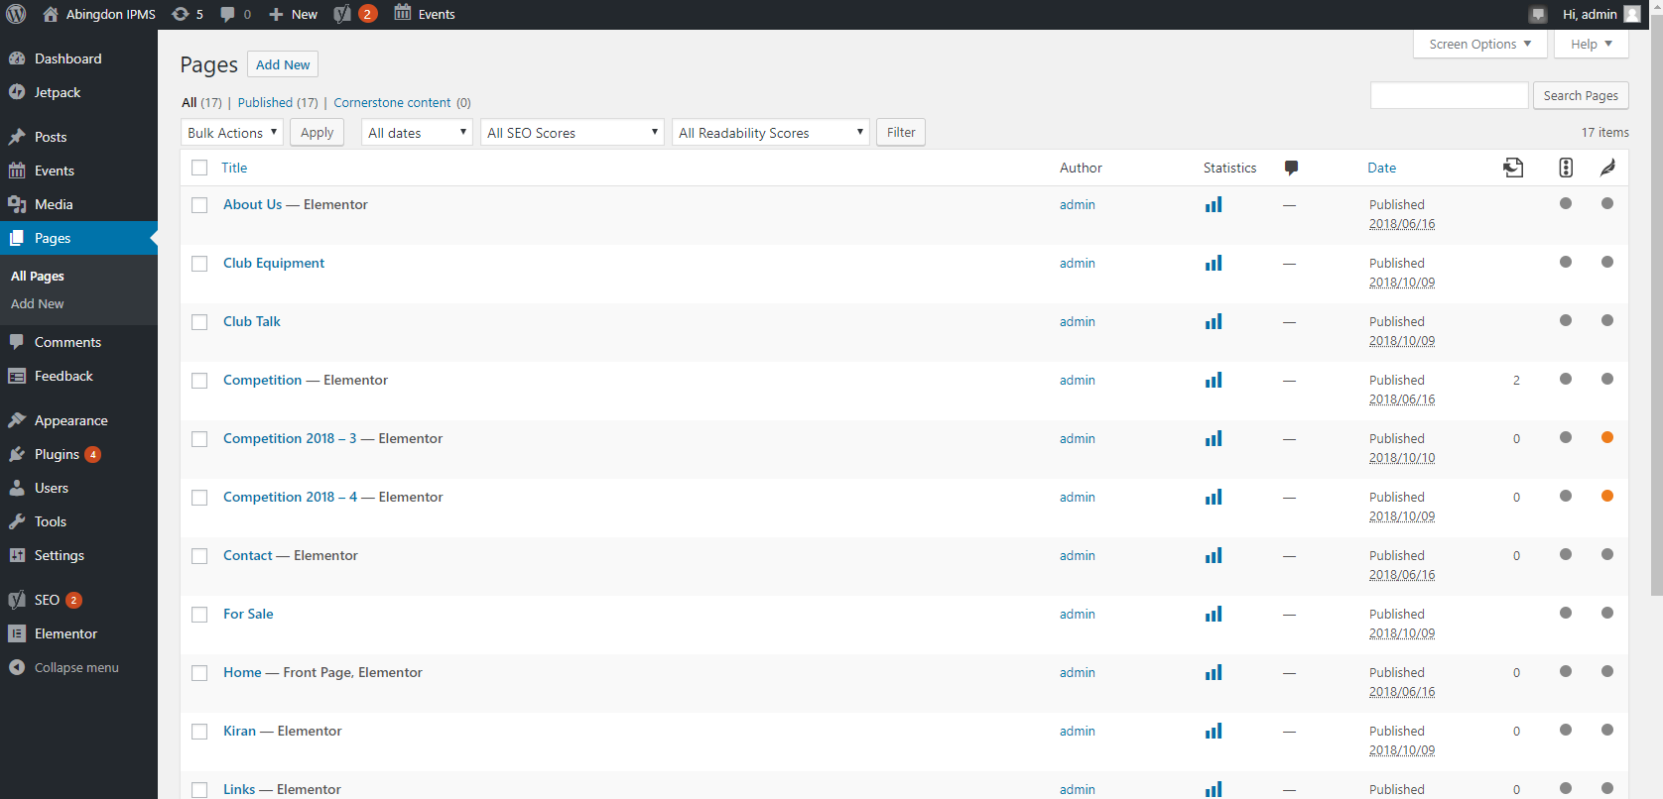

2 – Move cursor over the Home – Front page, Elementor and click on Edit with Elementor ,and we get:

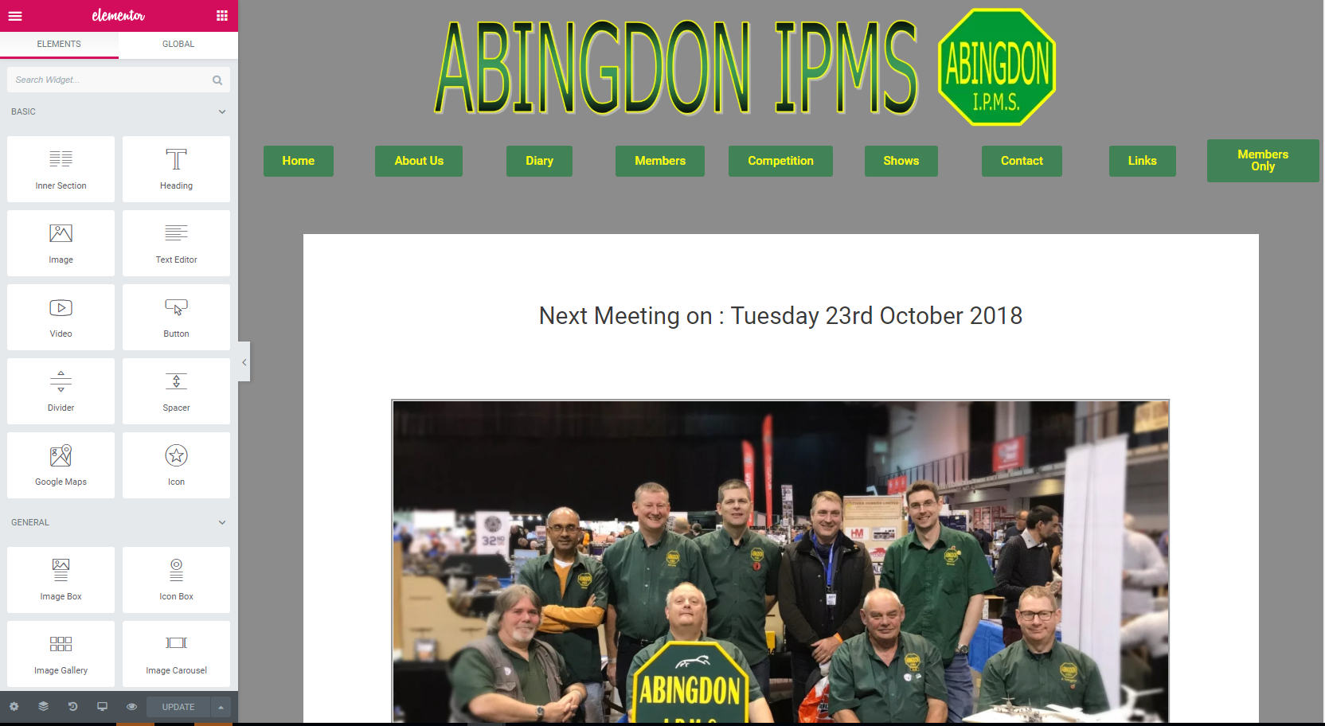

This is our home page.
On the left are the edit & functions that can be applied to the Middle of the screen.

3 – Move cursor over the ‘Next meeting On …’ box (above our Image) and click, we get

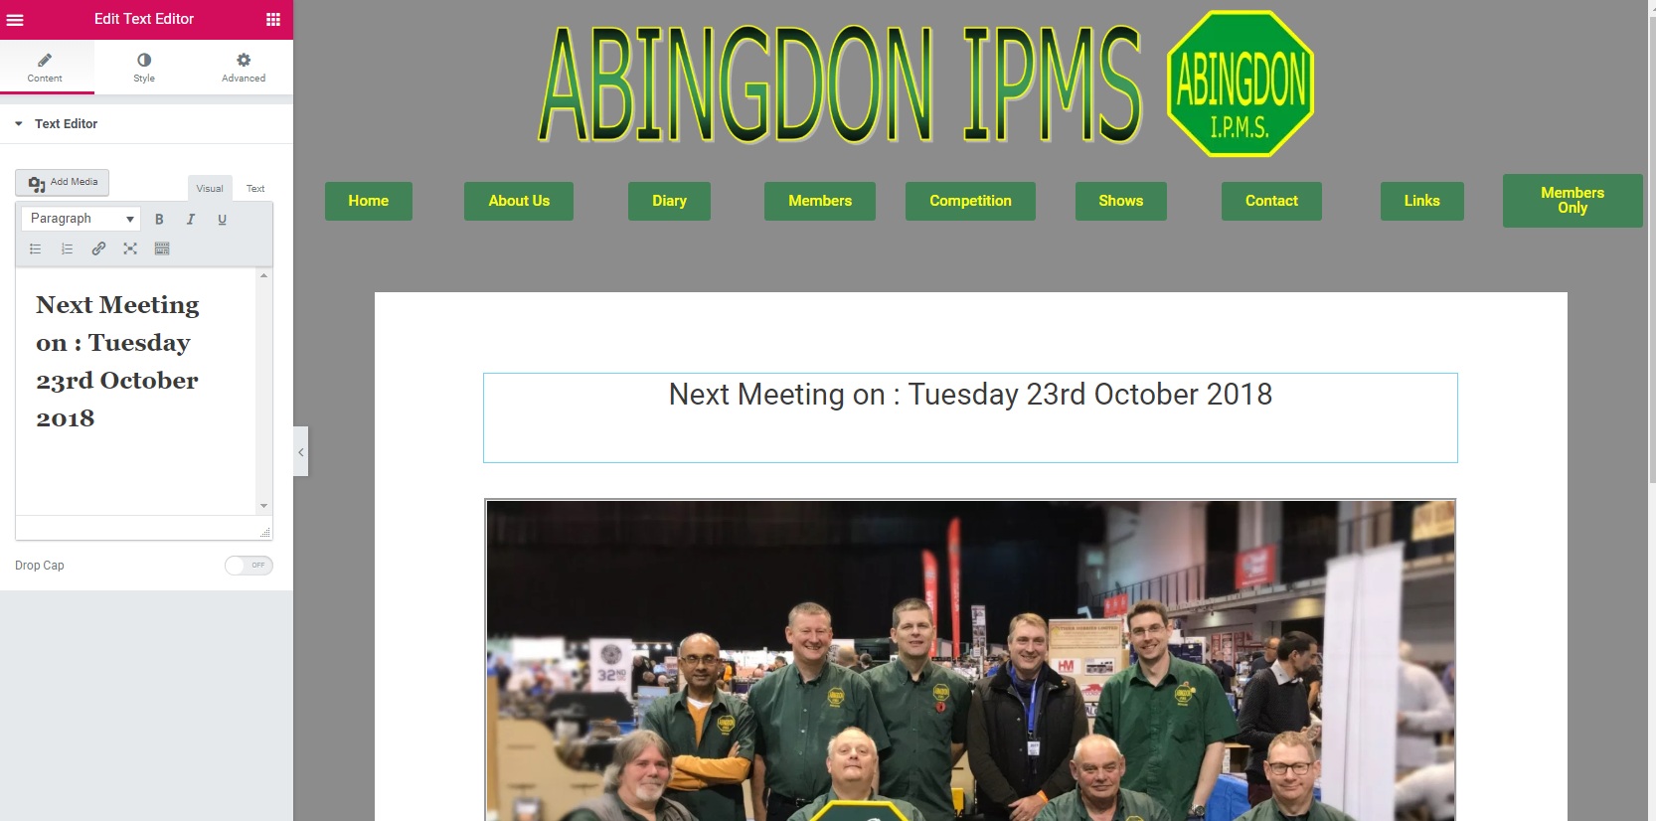

4 – Now on the left hand side you can see Edit Text Editor. As this is a text box we can amend the text in section 2(see below)

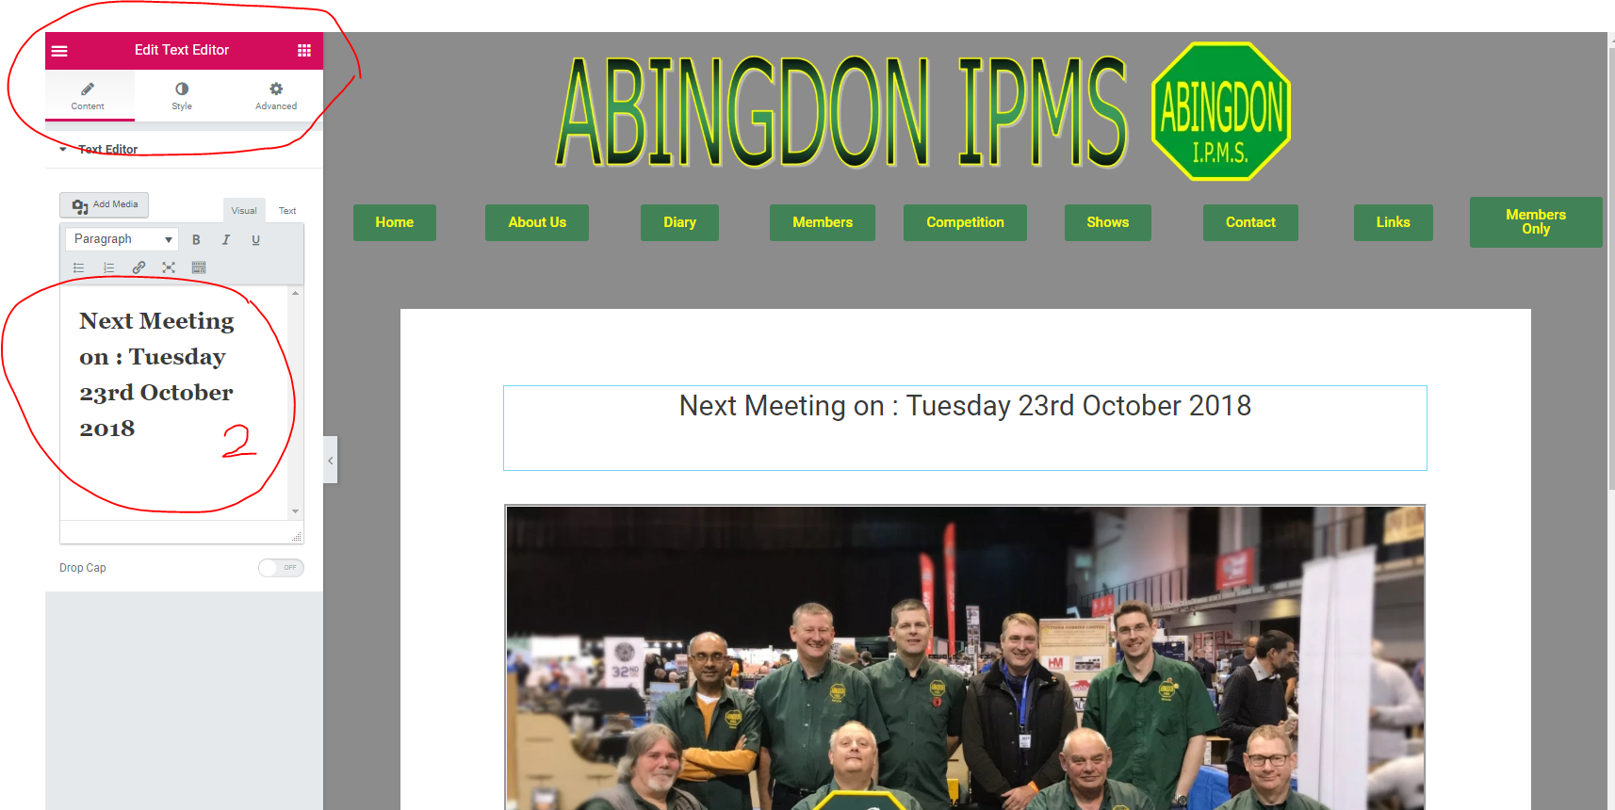

Change the date here to the next Club meeting/event.

Click on UPDATE (bottom left) as per:

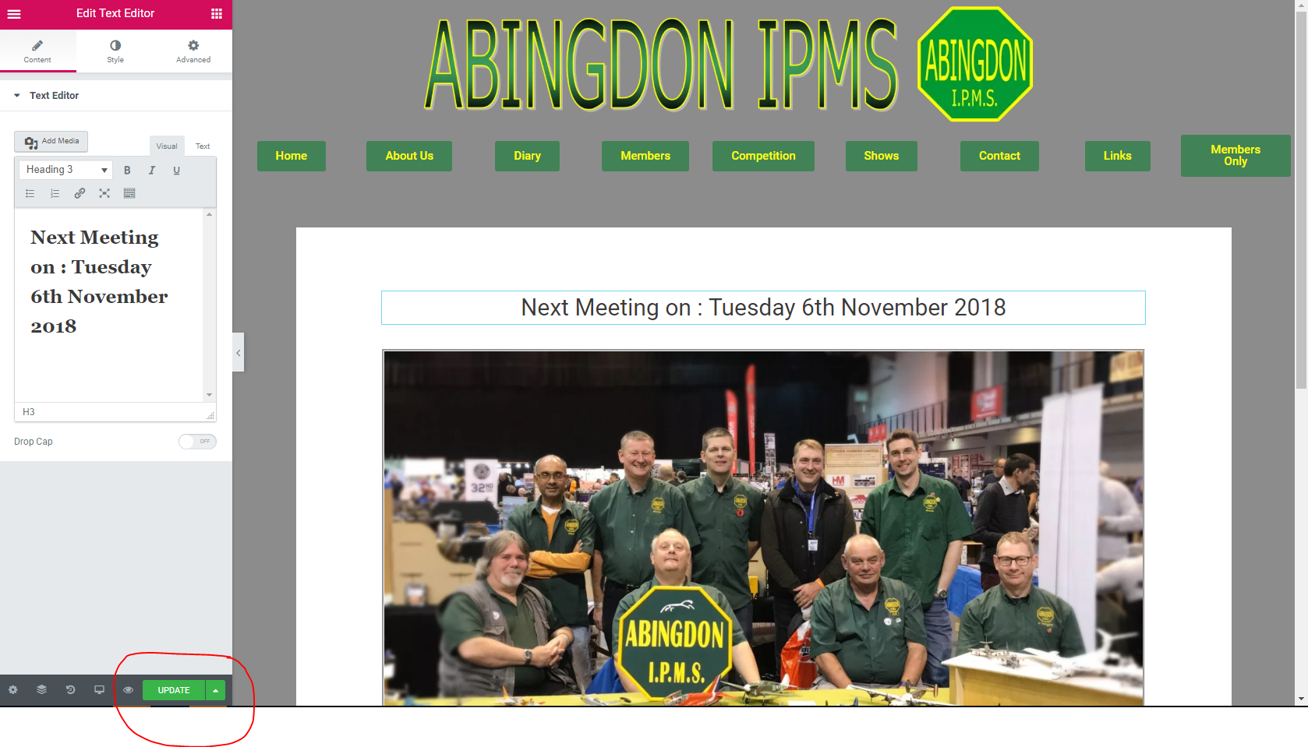

5 – Move to the Browse Window 2 which displays our web site http://www.abingdonipms.co.uk/
Refresh the page to show new date.

6 – Back to Edit Window 1, and time to exit the Elementor.
Click on 3 white horizontal bars at the top of the left hand side, as per:

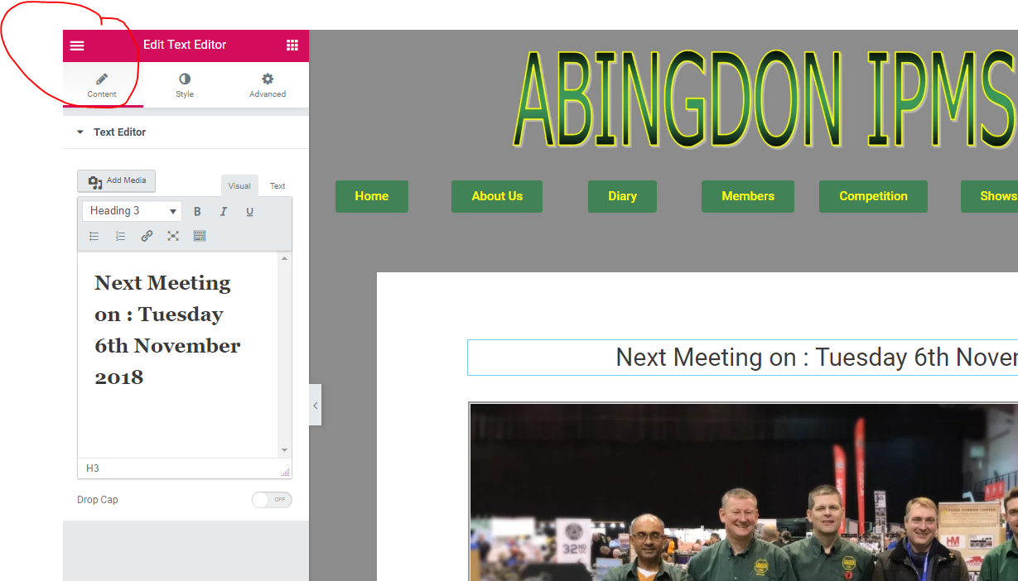

We get:
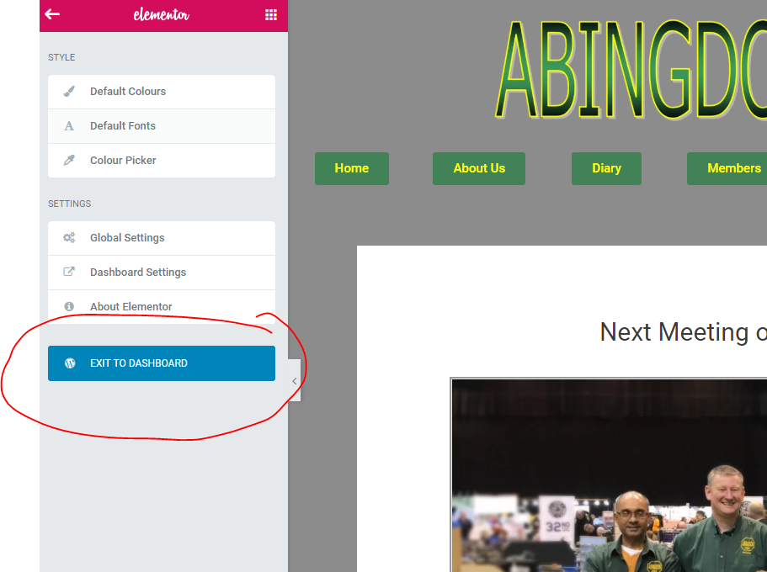

Click on Exit to DASHBOARD

This will bring us back to the Dashboard, as per:
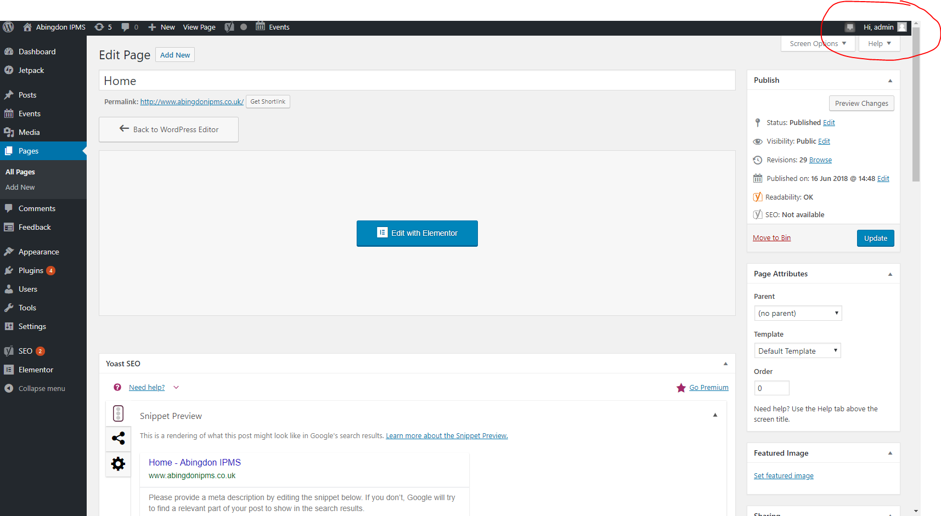

We can now sign out by moving the cursor over the Hi, admin section (top right hand side, see above) and click on Log Out.

How to add a Diary Event.

In Edit Window 1, click on events, we get:

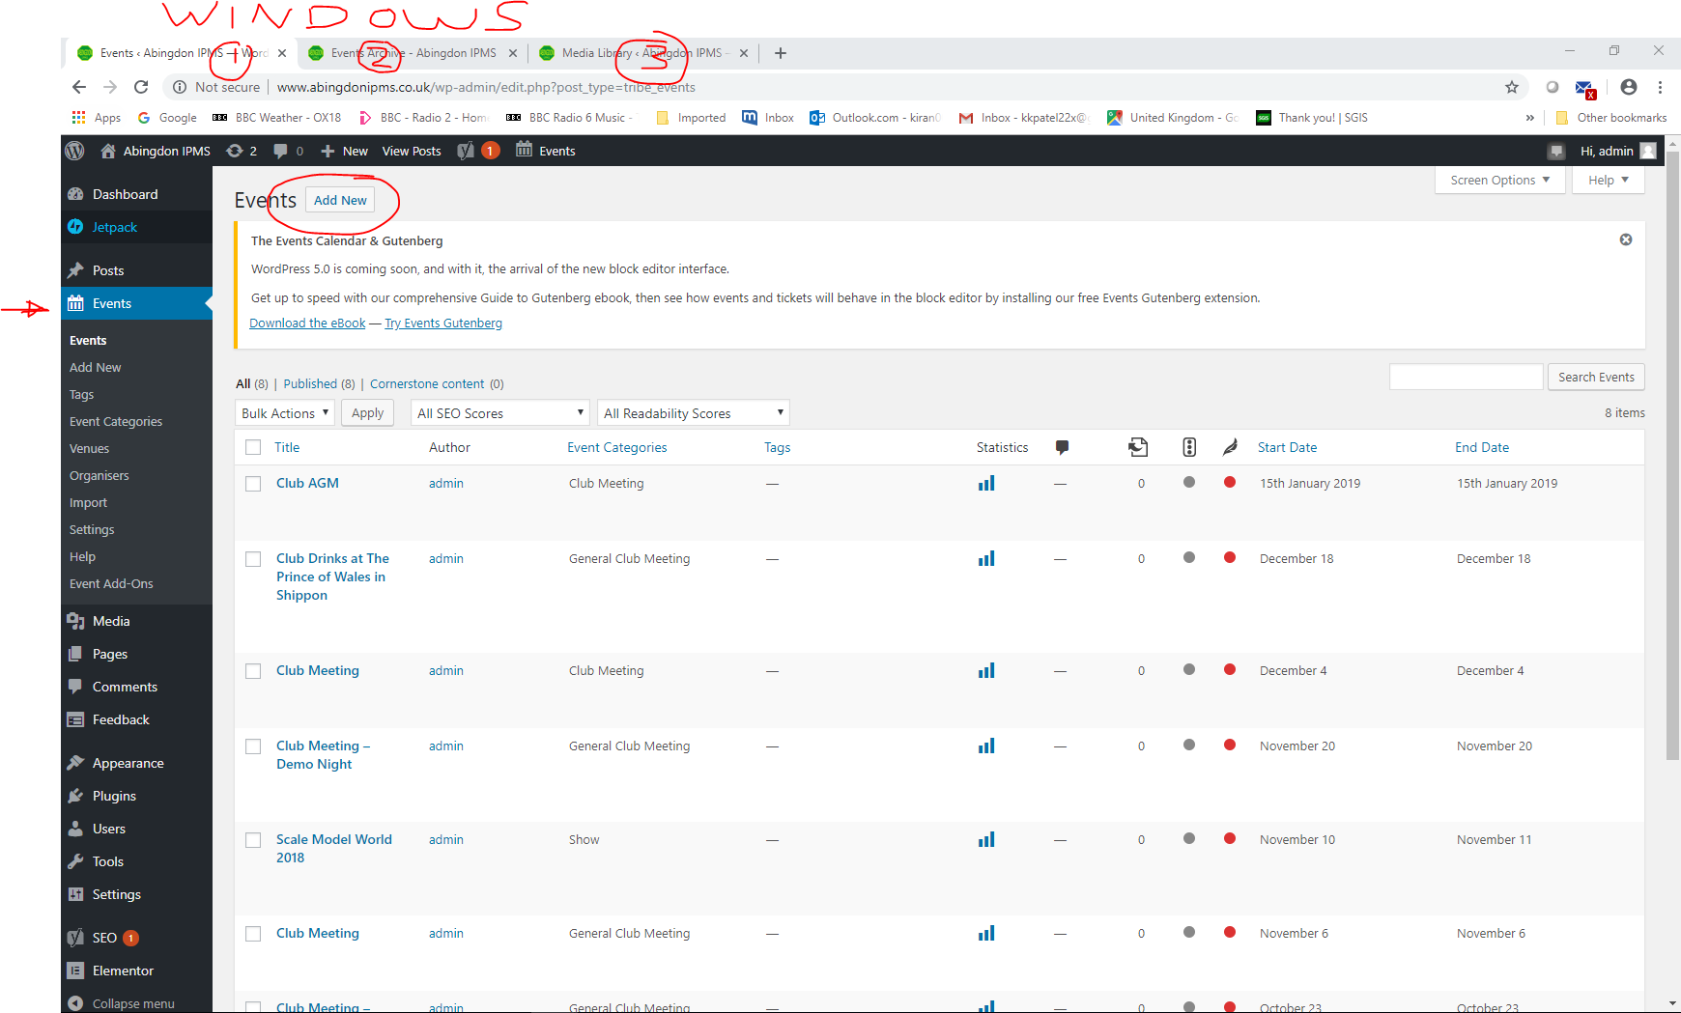

Click Add New
Enter your text into Enter title here ie ‘Club Meeting Test’
Scroll down and change date and time, location..etc
Scroll back up to top and click on Publish(top right side)

In Browse Window 2, refresh and view the changes.

How to add our Show flyer to the Shows page.

We will assume the Show has already been entered as per:
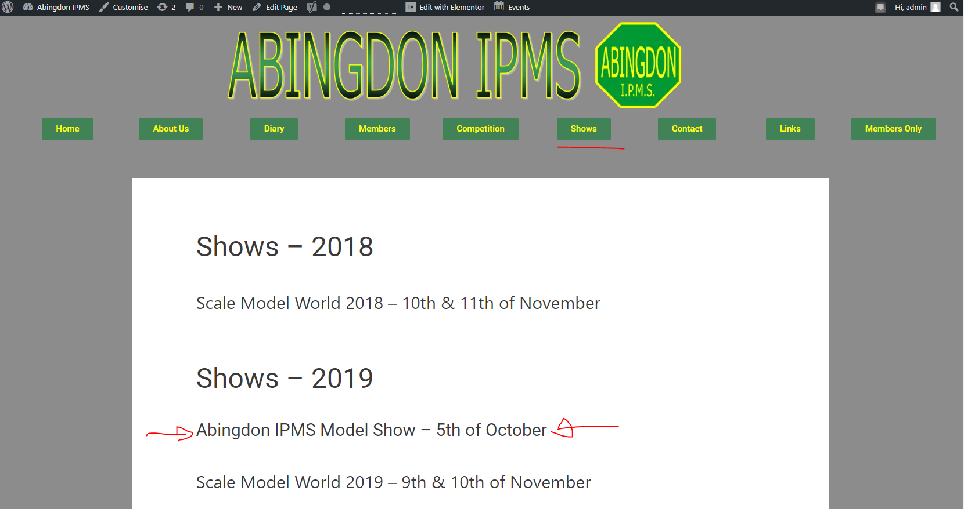

Goto media in Edit Window 1
Drag across the word**/PDF document from File explorer to Media
**Note a word document will not open in another window, it will be down load.

Click on Pages
Click on edit with Elementor on Shows
Click on our show (middle of Screen), as per
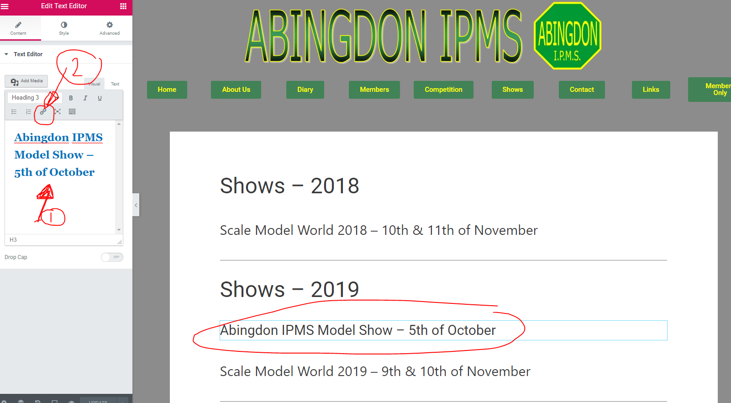

Note text ready to be edited on left hand side (see 1)
Hi-light text in 1 and delete.
Click on 2, this will allow us to link to media, url etc.

A pop up will appear and click on ‘Cog’ see below

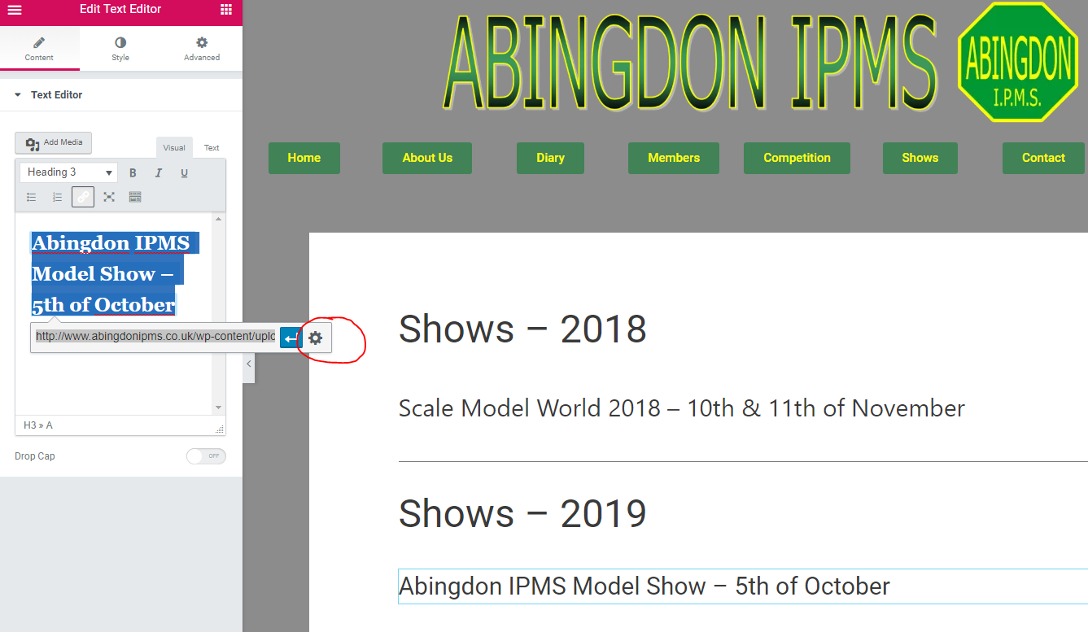

We now get:
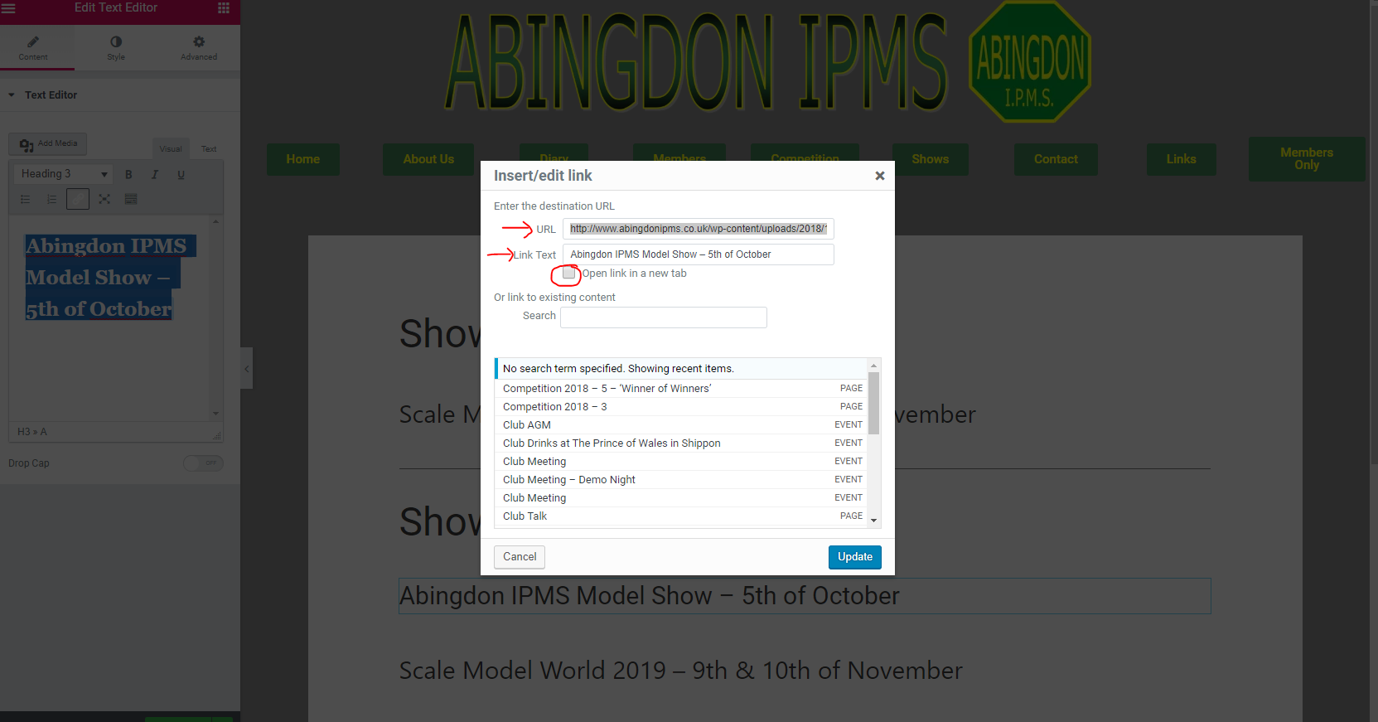

The URL is what we want to link to this page. In our case it’s the word/pdf document.

We can get this URL by
Going to Edit Window 3

so now we should have 3 windows open
1 Edit Window 1(where we are making the changes)
2 Browse Window 2(where we can see the changes)
3 Edit Window 3(this is where we are going to get the URL from)

Click on Media

So we should have this in our third window:
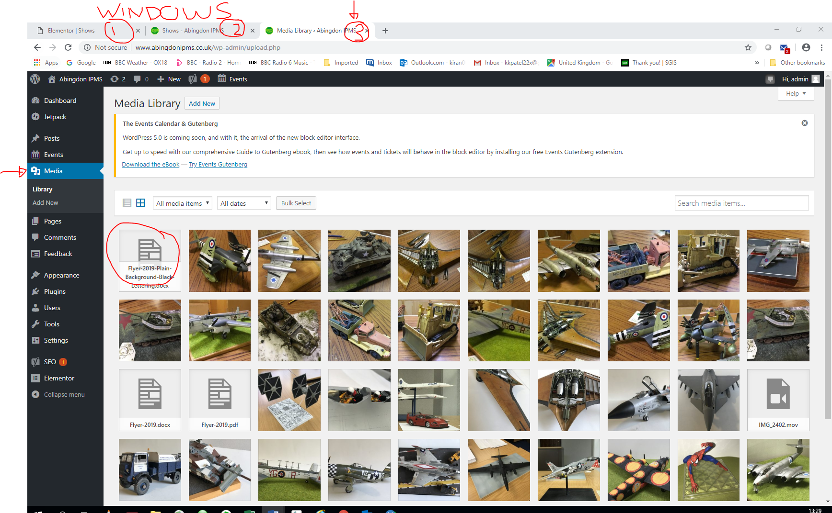

Click on the word/pdf document(see above), we get
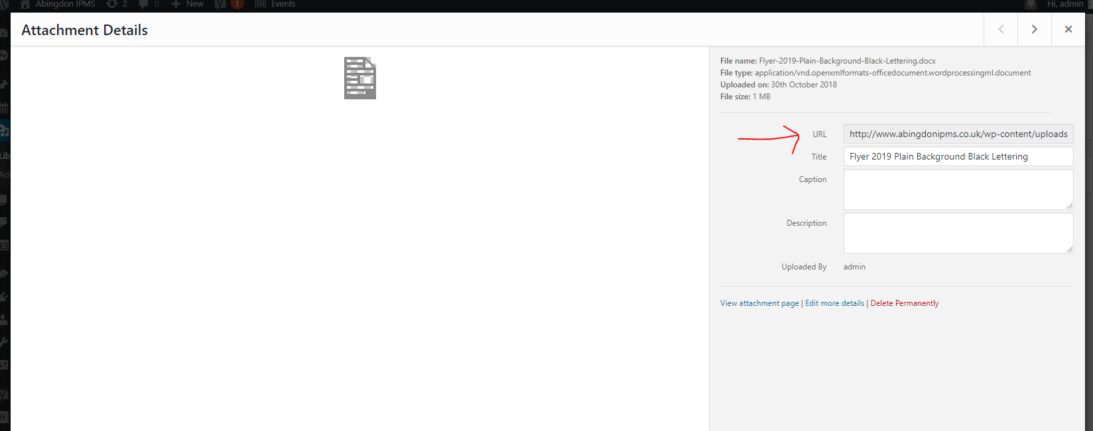

Copy the URL.

Back to Edit Window 1 and paste in URL.
Link Text is ‘Abingdon IPMS Model Show – 5th of October﻿’
And we can tick Open Link in a new tab if desired
Click on update
&
Click on Update again

Move to Browse Window 2 and refresh page and see if the link works!

If it works exit Elementor in Edit Window 1.
How to Change the password to Members Only.

In Edit Window 1
Click on Pages
Scroll down to Members Only
Click on Edit (NOT Edit with Elementor)
This will bring us into the Members Only page.
Click on Visibility: Password protected Edit (top right hand corner)
We get:

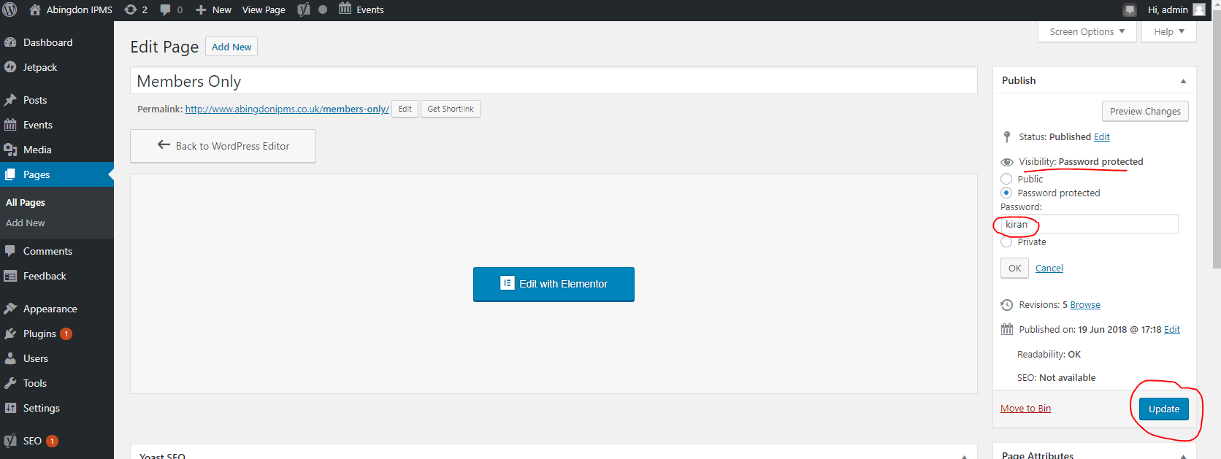

Change Password from kiran to airfix22
And click on update

Move to the Browse Window 2
Refresh page and test that it allows you to get in with the new password.

Back to Edit Window 1
Sign out

How to add new Competition Pages, Images & Text. ******* NOT COMPLETE***Still updating*******

1 Sign in on Edit Window 1
2 Make sure you can see the Dash Board
3 Click on Media, which gives:
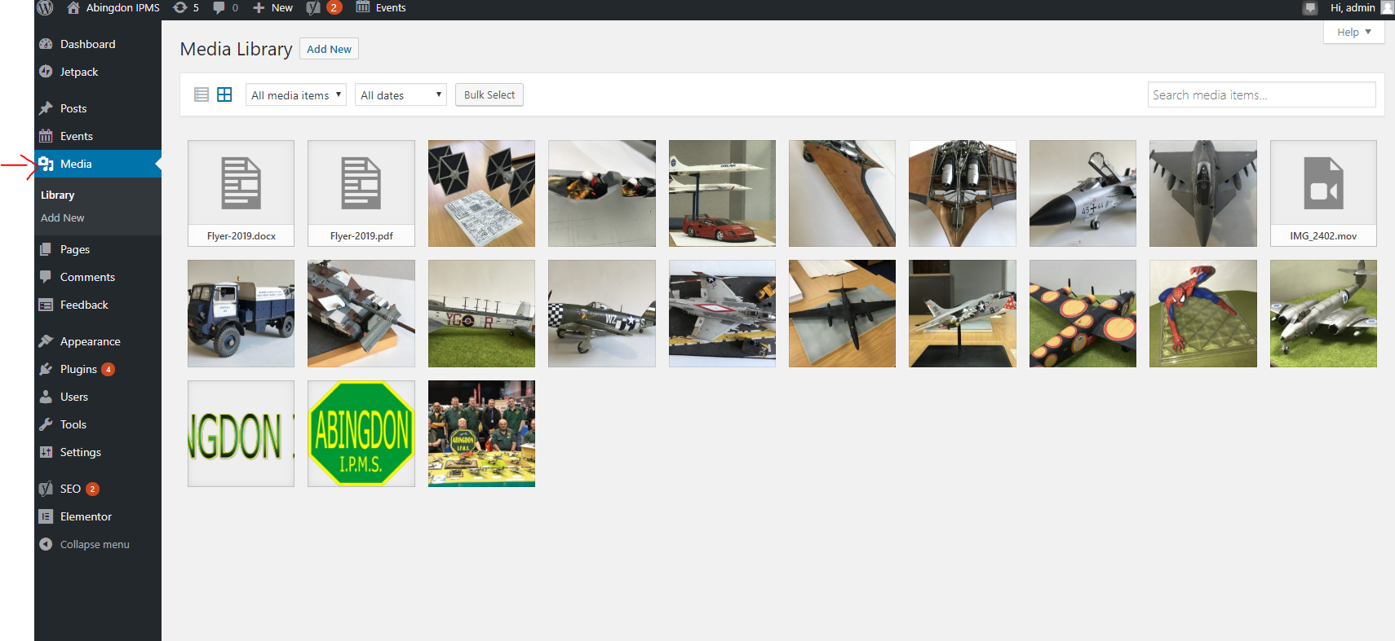

4 Now in another window (I use File Explorer) display/Select the images/documents you want to copy as per:

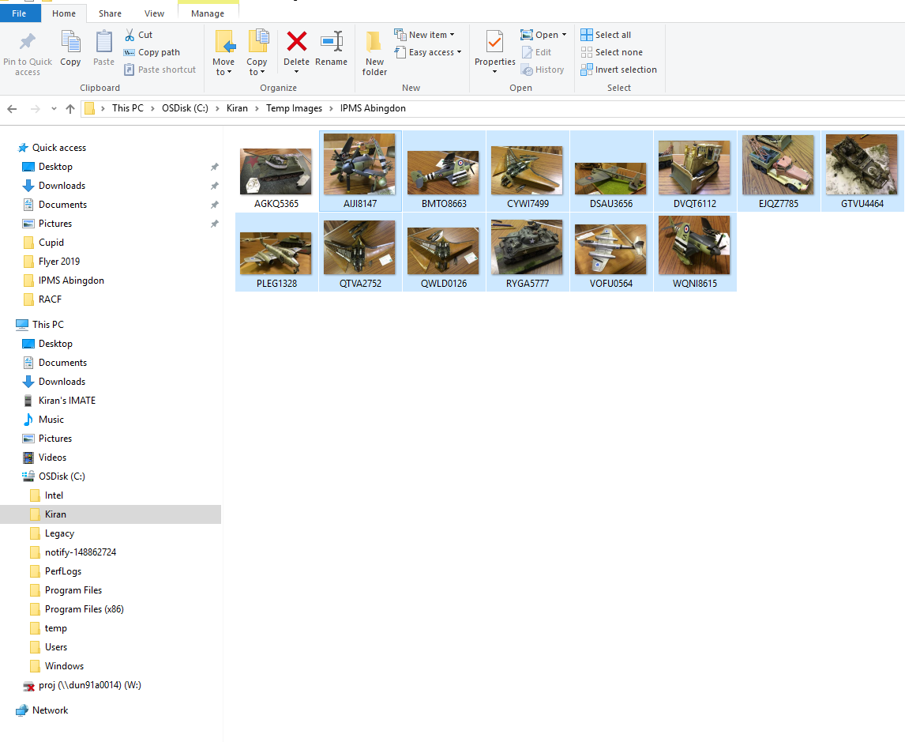

Drag selected image(s)/Document(s) to Media page.
Note you CANNOT Copy & Paste!

Which then gives:

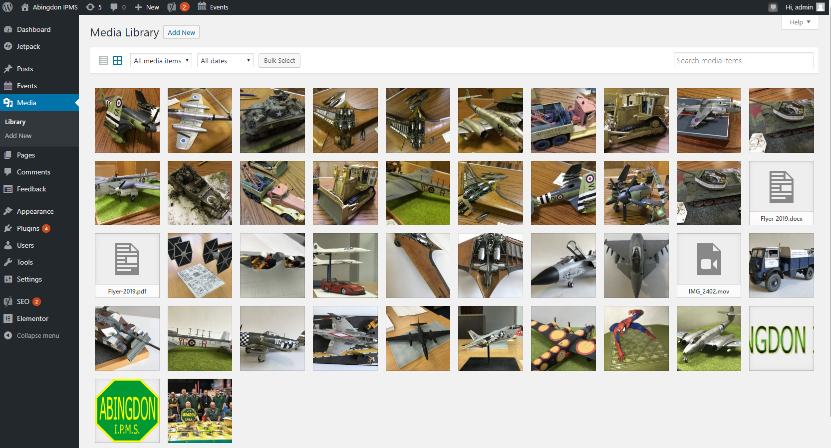

Media has now been copied and we turn our attention to creating pages to hold
These images, add text…etc

5 Click on All Pages under Pages and click on Add New (top left corner)

6 This will open up a new Page, Enter Title as per:

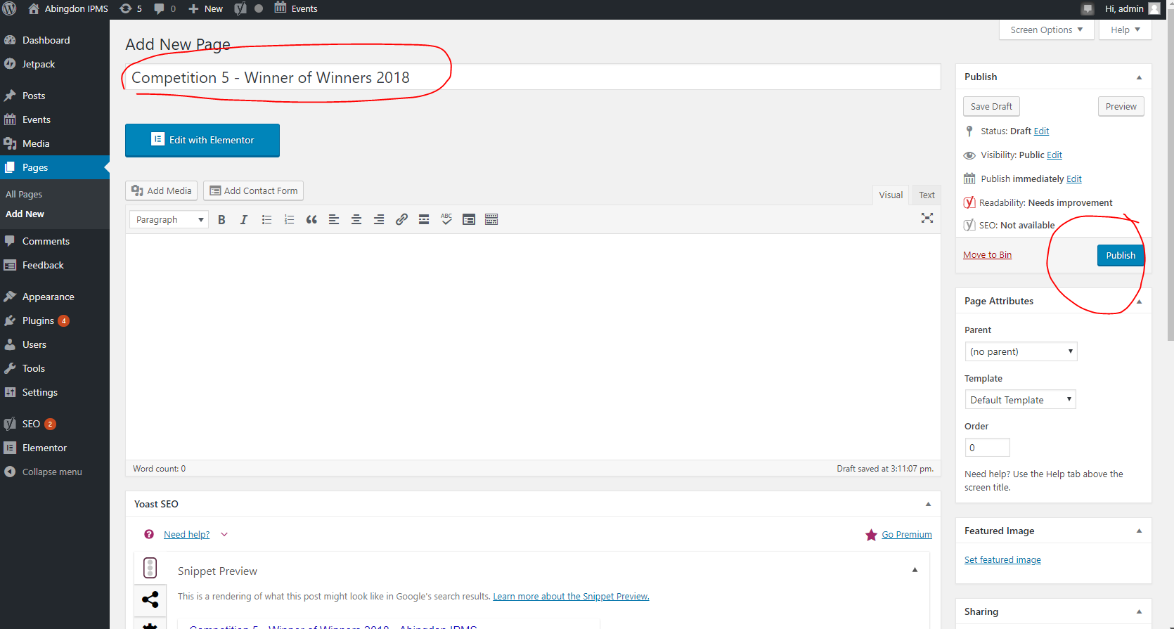

And click on Publish.

Now click on Edit with Elementor, this gives us:
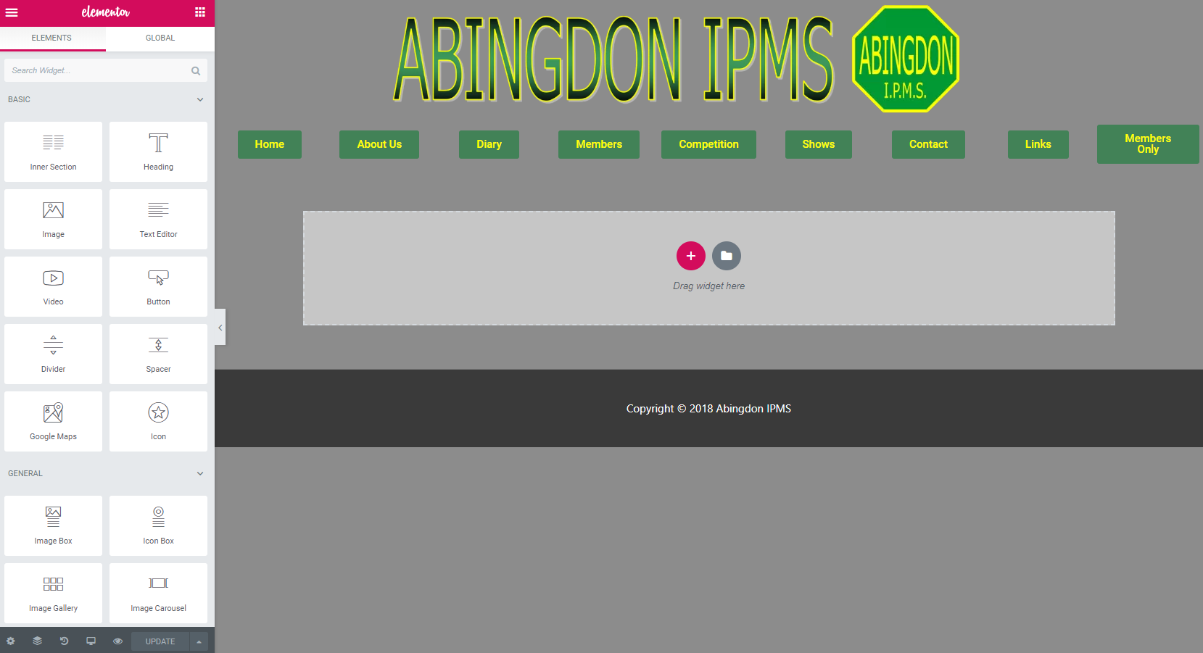

As you can see we have an empty page.

7 Now its time to decide how to break up/format the page.

To be continued!

Contact Details if you get into Trouble

Kiran
M: 0777-1790-331
H: 01993-852-186
E: kiran002@hotmail.co.uk

And if im squashed by a lorry on the M25 or hit by a plane at Fairford! please call

Ian Turnbul (Web Master who created all this for us)
M: 07805-079-543
H: 0162-174-3710
E: iturnbu1@gmail.com

